



Smartfarmer-IOT Enabled Smart Farming Application

# Team members: Guided by:

Ravikiran R Kanthimathi N

Nabushan B Pranesh RR

Navaneetha Krishnan

# BRAIN STORMING IDEAS

The main objective of this project preparation is to enable the accessibility of the modern techniques to the farmers in order to make their work easier and in this smart Farming project we use IoT and a few serial communication devices which allow the farmers to control the process of irrigating the fields by their mobile. Through this process we can help the farmers to irrigate their fields whenever necessary irrespective of them being there which requires man power to look over and also it helps us to provide needed amount of water to the crops. We also Implement Moisture sensor in order to Monitor the Soil Moisture. Then According to that Suggestions can automatedly Provide about how much Amount of Water need to be Irrigated to the Field. We are also going to implement Temperature sensor in the Field in order to provide suggestions to the farmers about the climatic conditions.

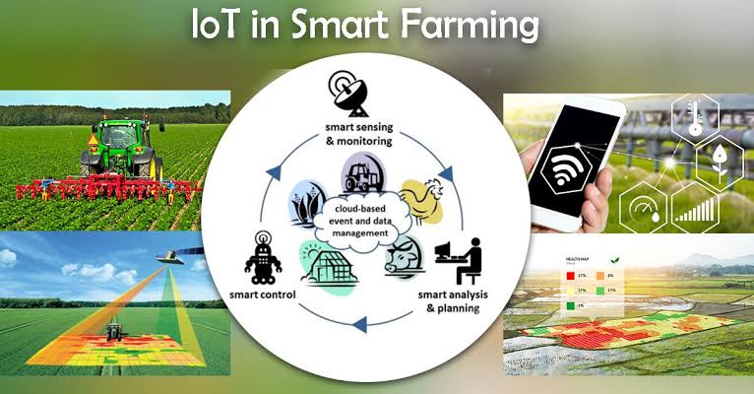

**RELATED WORKS:**

The Farmers use the Irrigation system (using motor) in the Field to deploy the water. But nowadays due to the less Manpower and Water Drought in some areas we can use the Technology to overcome those troubles. In this Smart Irrigation project we use some IOT based devices which are capable of automating the Irrigation process by Monitoring the amount of water flow and Analyzing the moisture control of the soil. Through this system the Farmers will be able to control the Irrigation system irrespective to the manpower and also consume needed amount of Water.

In the Smart Irrigation system, we Some IOT devices and a App using Cloud which transfers Data from the Farmer to the motor. In Farmers mobile we install a App using cloud through this the Farmer will be able to release the needed or Certain amount of water for the particular field. In the App it will have certain options like Low Amount of Water, Medium Amount of Water, High Amount of Water. The Motor will also be disabled by the data given by the Moisture control sensor. The moisture sensor will give the data about the soil of particular field to the farmers Mobile phone accordingly the farmer will be able to deploy the needed amount of water to that particular Area. The Data given by the farmer is transmitted to the Node MCU which is fixed in the Field. The Node MCU Transfers the analyzed data to the ARDUINO UNO through the Lora Shield (wireless modulation device). The ARDUINO UNO is Situated near the Motor Controller and gives the output information to motor regarding the deploying amount of water. Accordingly deployed amount of water flows into the particular fields.